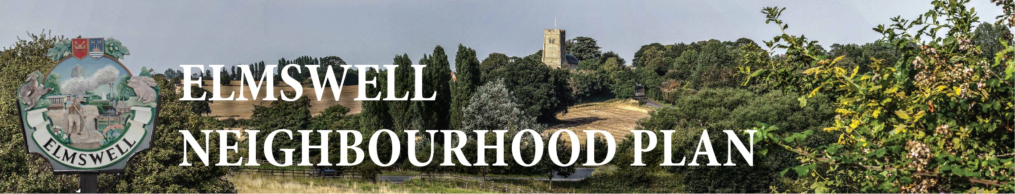

MINUTES OF A STEERING GROUP MEETING
held on 28th May 2015
7.00pm at The Blackbourne
Present: Marian Abbott, Julie Cole, Peter Dow, Terry Garner, Peter Goodridge,
Sarah Mansel (Ch.), Fred Pallett, Shaun Pratt, Lesley Reed, Ann Richards,
Julia Taber.
Guests Gillian Benjamin of CAS
Rachel Hogger of Urban Vision
1 Apologies were noted from Philip Blissett, Peter Edmonds and Mary Feeney
2 The Meeting welcomed new Parish Council members Lesley reed and Julia Taber and
Rachel Hogger and to Rachel Hogger from Urban Vision.
3 The Meeting agreed that Ann Richards and Marian Abbott were key contributors to the
Group and, in line with their wishes, should be asked to continue to serve although no longer
appointed to do so by the Parish Council.
4 The Minutes of the last meeting held on 17th March were approved as a true record.
5 There were no matters arising from those Minutes and not dealt with as an Agenda item.
6 It was noted that the raw data from the Household Questionnaire, which would be the
subject of in depth analysis subsequently, indicated a respectable 30% response
comprising 1,080 submissions with 91% support for a Relief road and a majority accepting
that development must happen outside of the current development boundary.
7 Rachel Hogger gave a resume of the services which Urban Vision would offer if engaged
as referenced in their Plan Support proposal. There was discussion regarding various
aspects of the process.
8 In light of Rachel’s presentation it was agreed that Peter G & Ann would produce some
relevant demographic data, that Peter D, Fred and Gillian would identify the ‘Big ticket’, key
issues, items to emerge from the raw questionnaire data. Julia and Marian agreed to
tackle the questionnaire distribution at Thurston School. All to be re-visited at an interim
meeting ready for a ‘Vision workshop’ with Rachel in about 6 weeks time. Meanwhile
Rachel agreed to write and advise on Local Plan issues, how to tackle the traffic issues and
copy across the recent Draft of the Newport Pagnell Plan which relates to the Elmswell
scenario.
9 There was no other business for discussion, to be noted or for inclusion on a future
agenda.
10 The date of the next meeting was agreed as 25th June at 7.00pm.
11 The Meeting closed at 9.10
Peter Dow
24.06.15

